

**Installation Manual**

Charity Second-hand Online Store

**Revised records**

|  |  |  |  |
| --- | --- | --- | --- |
| **Update Date** | **Version** | **Description** | **Name** |
| 16/05/2020 | v.1.0 | Initial version | Cong |
|  |  |  |  |
|  |  |  |  |
|  |  |  |  |

Contents

1. JDK 3

1.1 JDK Install 3

1.2 Set Environment Variable 6

1.3 Validation the effectiveness of JDK 12

2. Database install 14

2.1 Set MySQL install 14

2.2 Set Environment Variable 25

2.3 Validation the effectiveness of MySQL 27

2.4 Initialize data 28

3. Tomcat 29

3.1 installs 29

3.2 Validation 30

# JDK

## JDK Install

* Validation JDK installation files. File name: jdk-12.0.1_windows-x64_bin.exe
* Run the JDK installation package and click next。

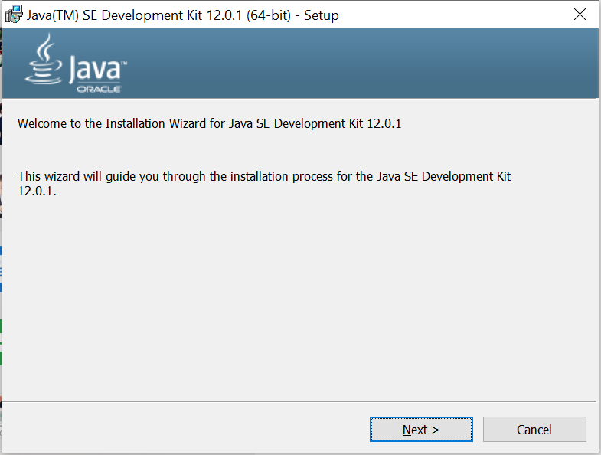

Select the installation path. Default path is：C:\Program File\Java\jdk-12.0.1\

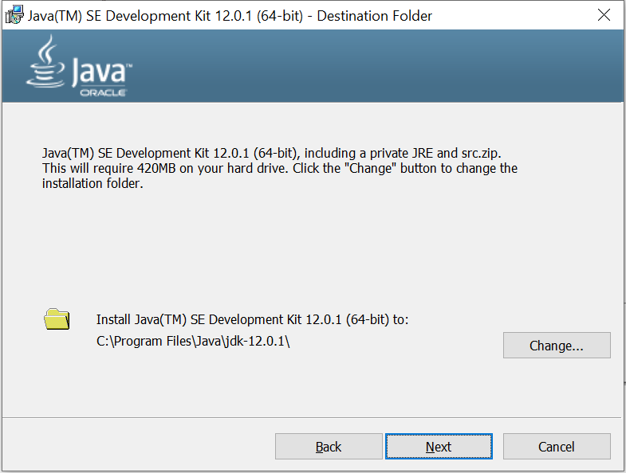

Installing

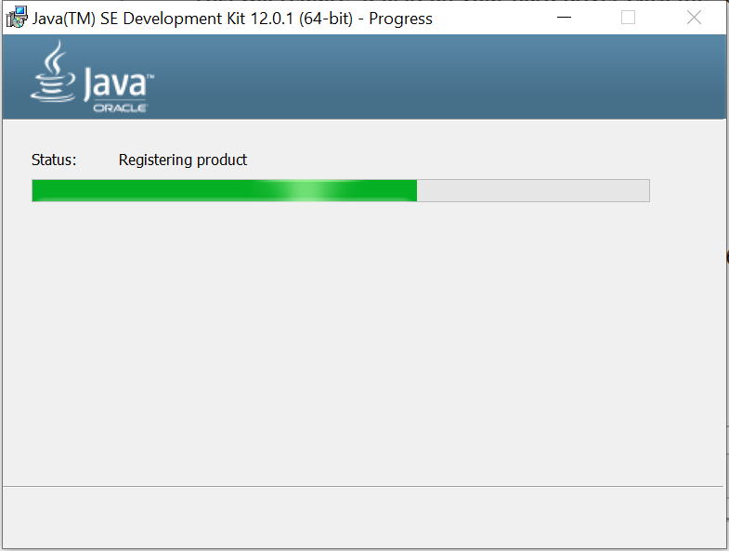

Click the close button to finish installation.

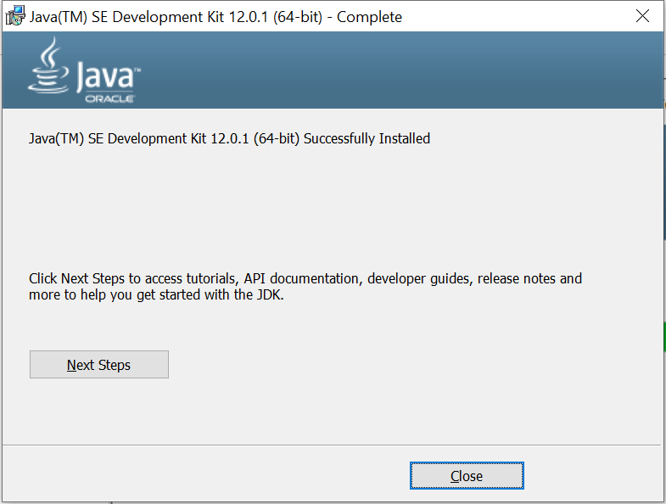

## Set Environment Variable

**Windows 10**– Search for **Environment Variables** then select **Edit the system environment variables**

Click the **Environment Variables** button.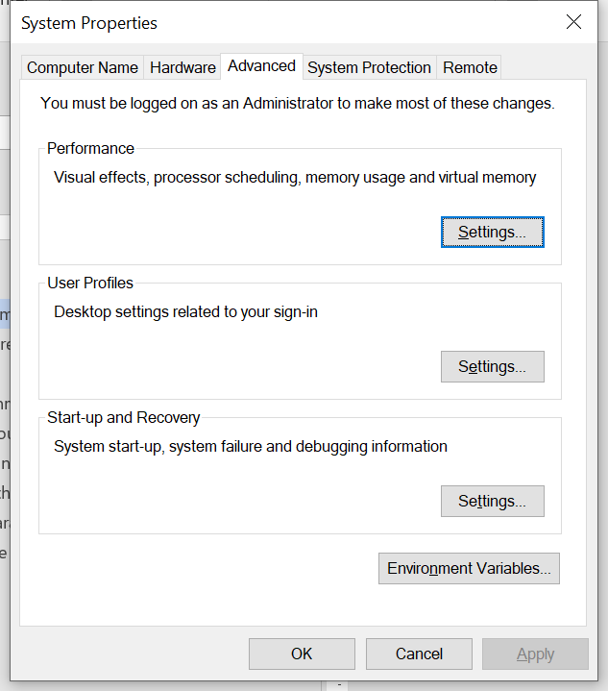

Under **System Variables**, click **New**.

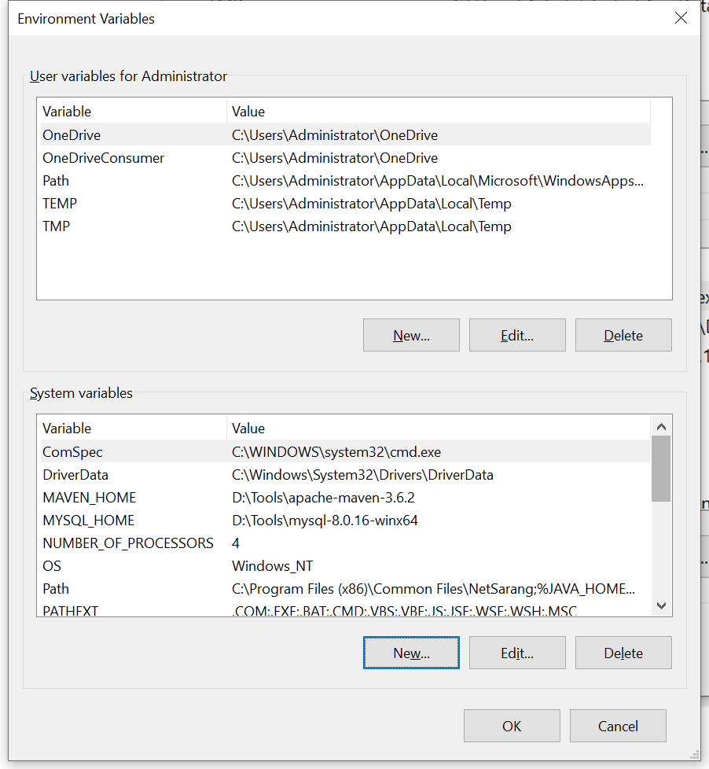

In the **Variable Name** field, enter:

Variable name: JAVA_HOME

Variable value: (JDK installation directory)

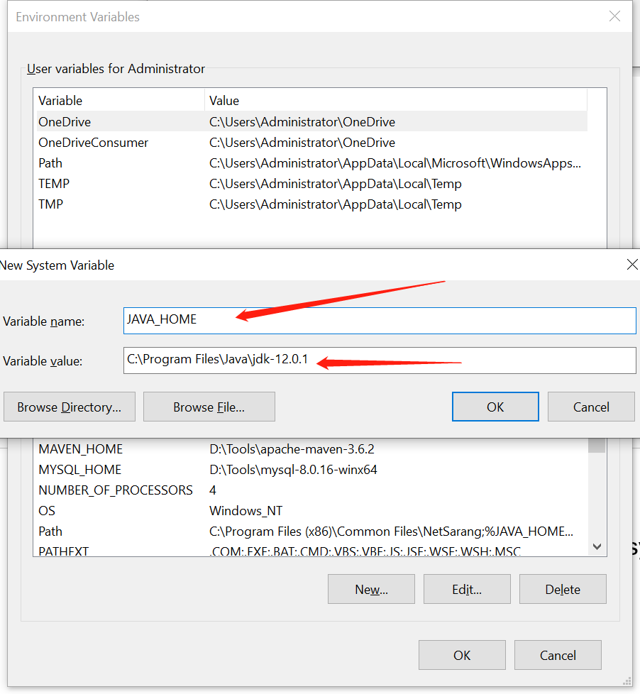

Click **OK**and **Apply Changes** as prompted

Update system path. In system variables, select the path and then edit it.

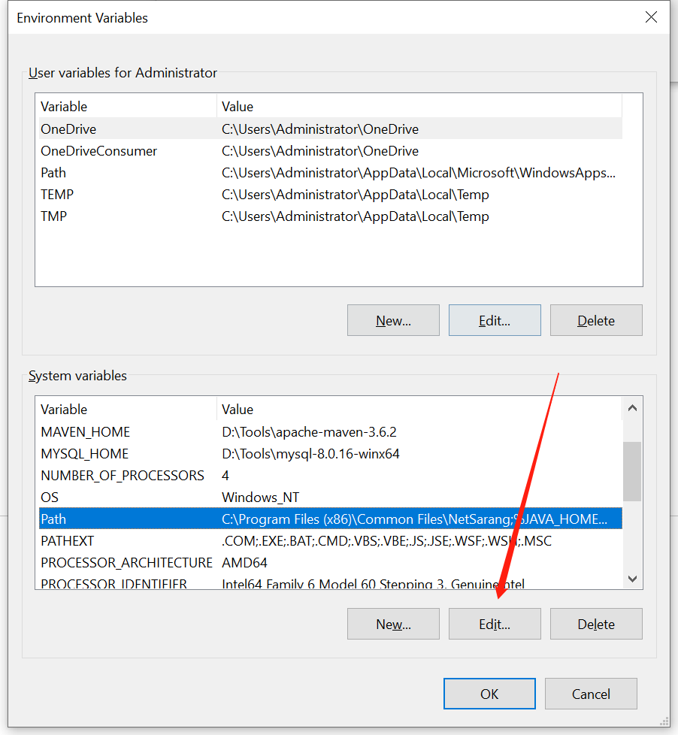

Open a new command prompt and type in “%JAVA_HOME%\bin”

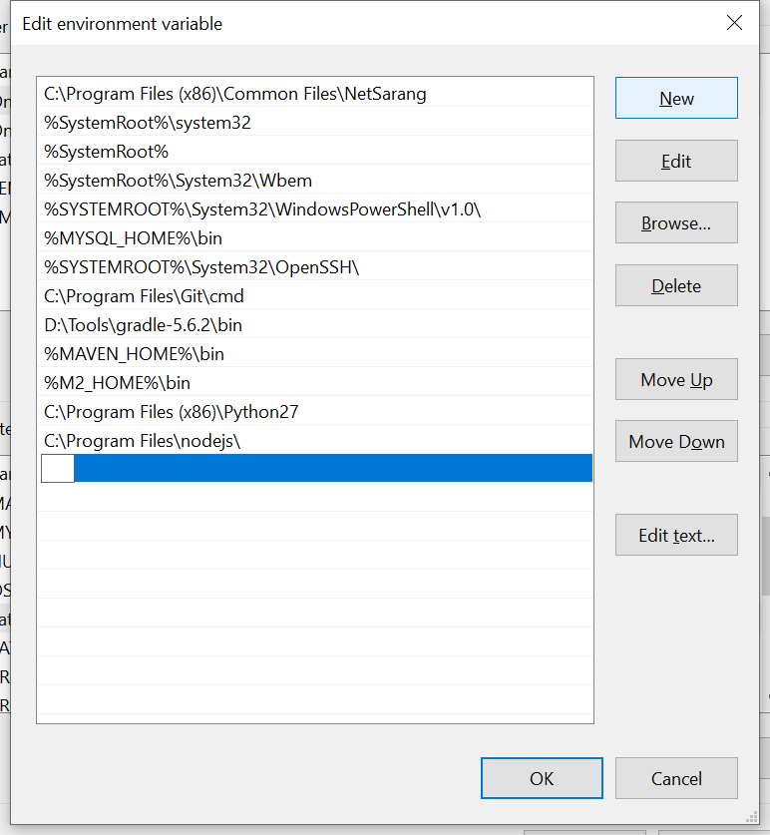

Click the “OK” button to exit the setting.

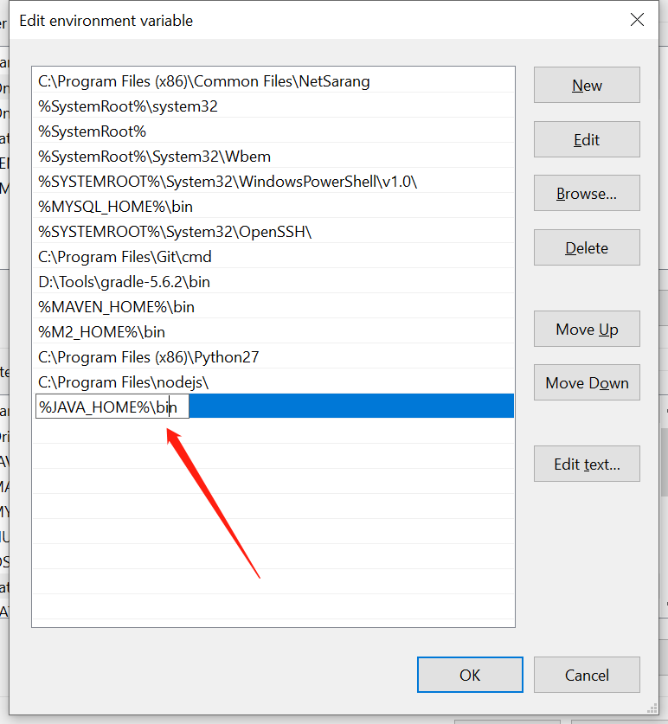

## Validation the effectiveness of JDK

Open Command Prompt (make sure you Run as administrator) and type in “echo %JAVA_HOME%”. As flowing screenshot shows, this will print out the directory JAVA_HOME points to or empty line if the environment variable is not set correctly.

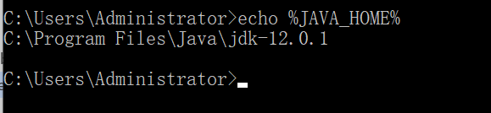

Now type in “javac -version”. this will print out the version of the java compiler if the Path variable is set correctly or “javac is not recognized as an internal or external command…” otherwise. If it can print the version number, that means the setting is successful.

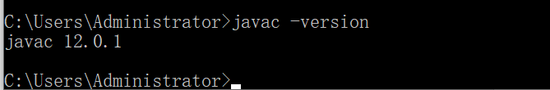

# Database install

## Set MySQL install

Check that the name of the installation file is mysql_installer_community_V5.6.21.1_setup.1418020972.msi

To install MySQL using the MySQL installer, double-click on the MySQL installer file and follow the steps below:

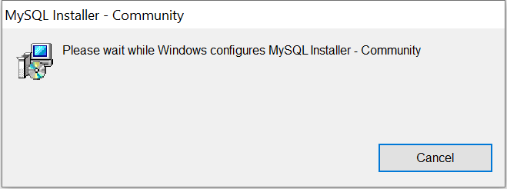

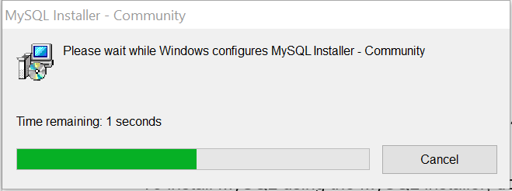

On the **License Agreement** page, click the**I accept the license terms** box and click **Next**.

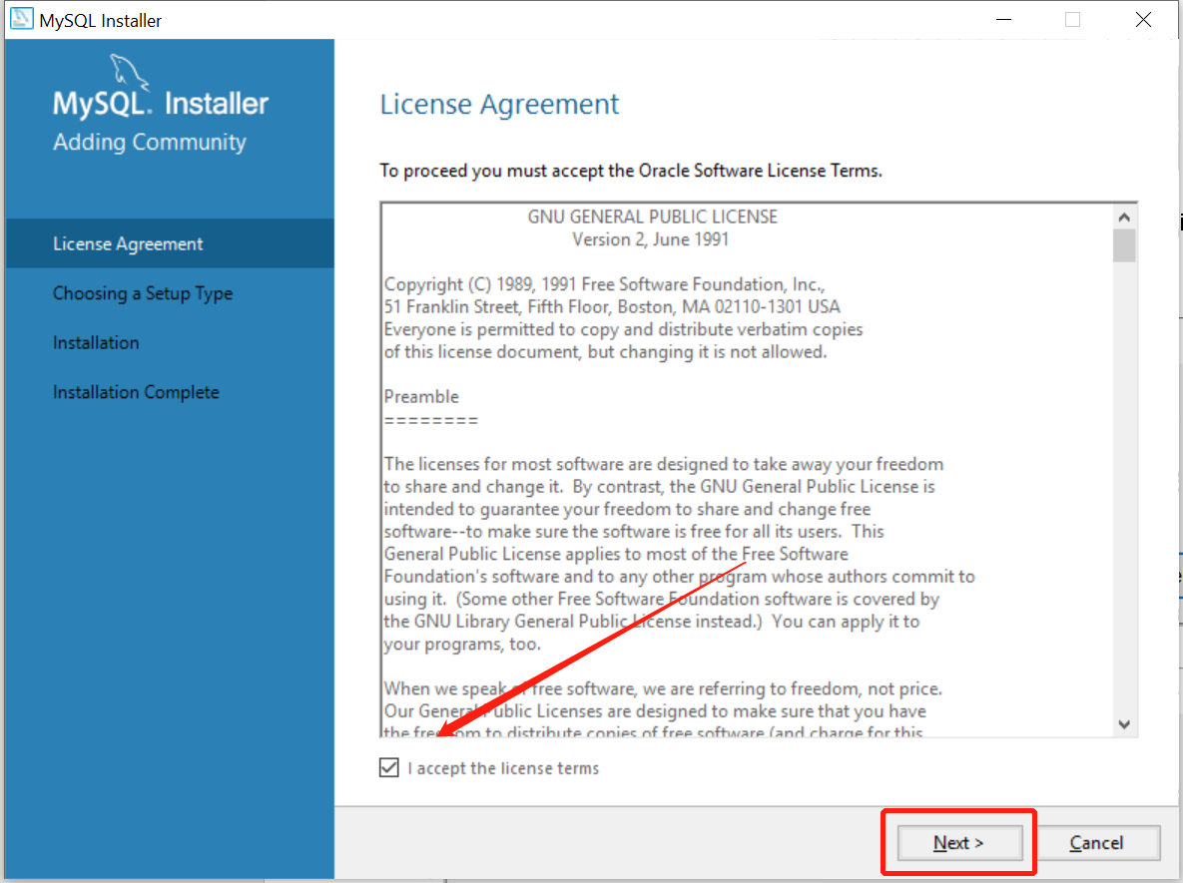

On the **Choosing a Setup Type** page. select **Sever only** and click **Next**.

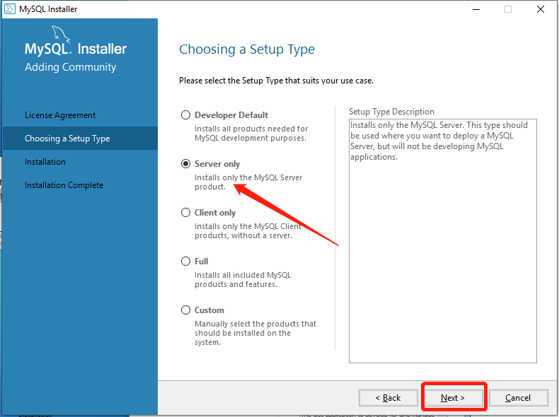

On the**Installation Progress** page, click “Execute” to install the MySQL server.

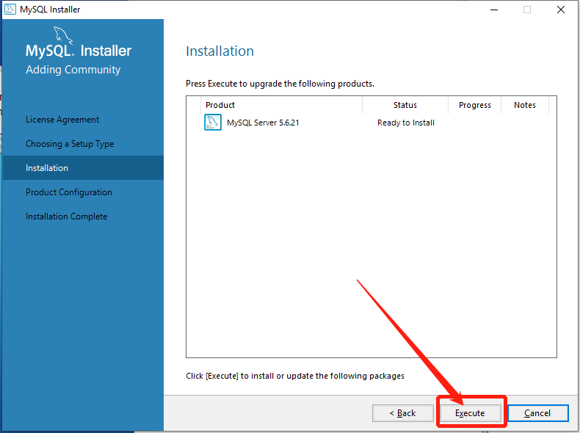

Once MySQL server is installed click **Next**

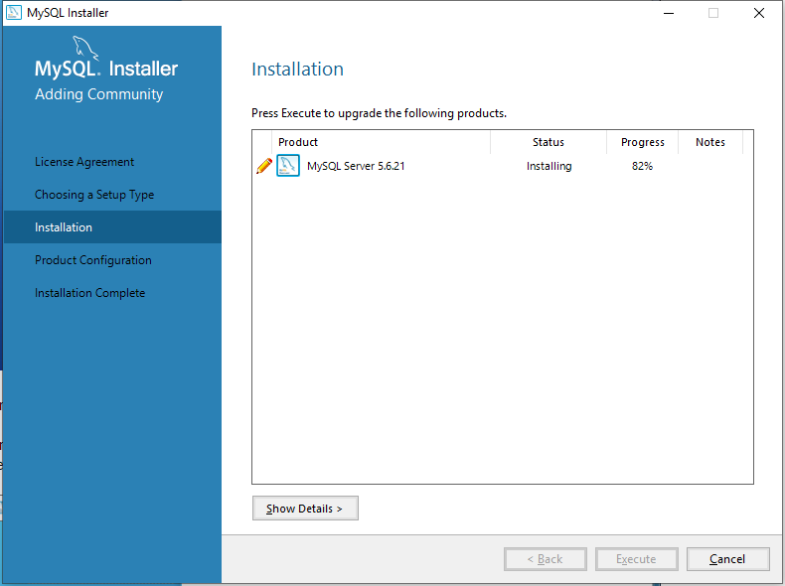

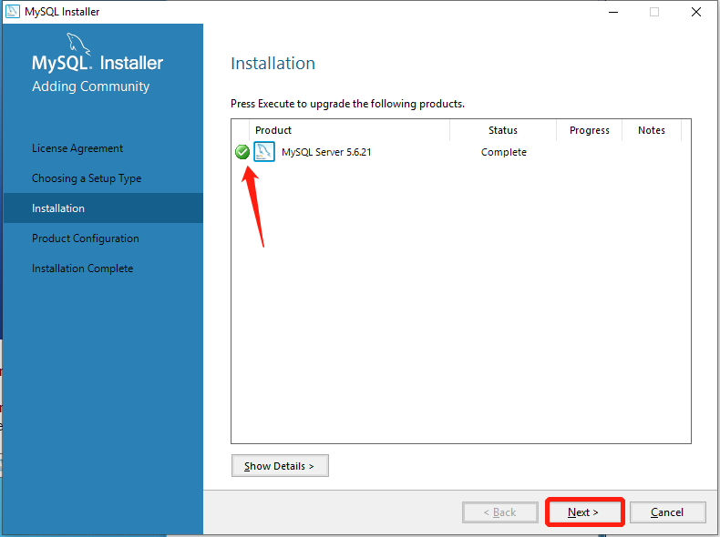

On the **Configuration Overview** page, click **Next** to set up the configuration

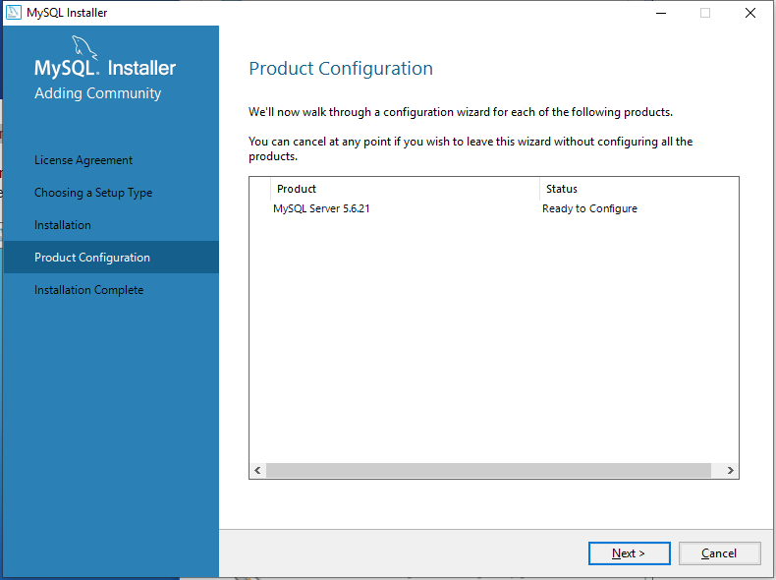

On the **MySQL Server Configuration** page (1/3), make sure the default **Port Number** is **3306**, keep all the defaults and click **Next**.

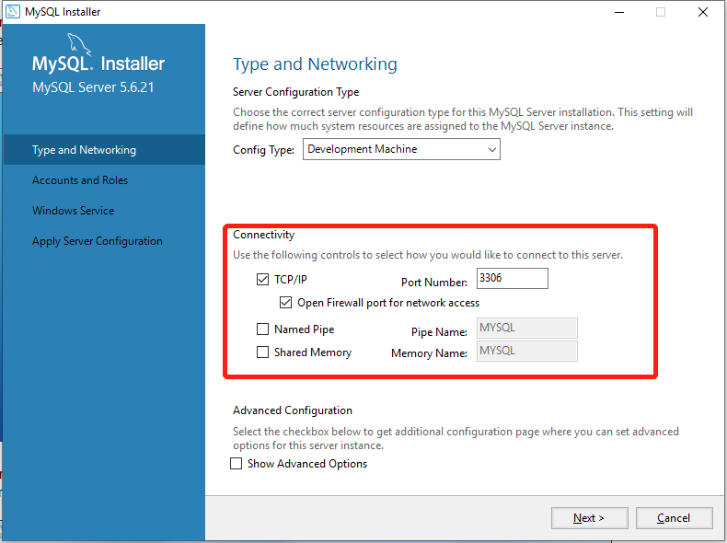

On the next **MySQL Server Configuration** page (2/3), choose a password for the root user, type it in, and write it down so you have it for future, then click **Next**.

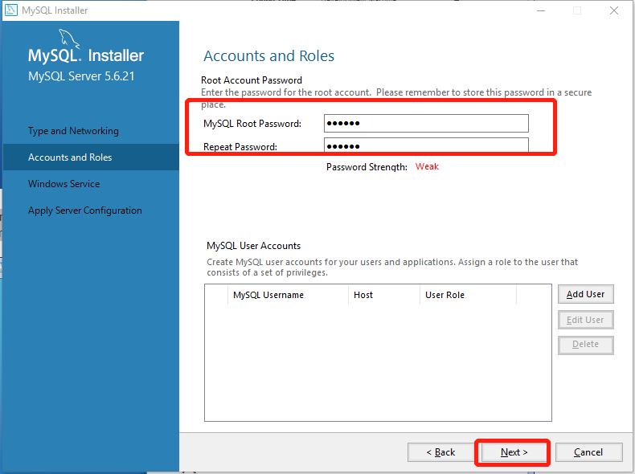

Make sure the following two items are selected by default:

**Start the MySQL Server at System Startup**   
**Standard System Account**

This installs MySQL as a Service and starts MySQL automatically each time you start your computer.

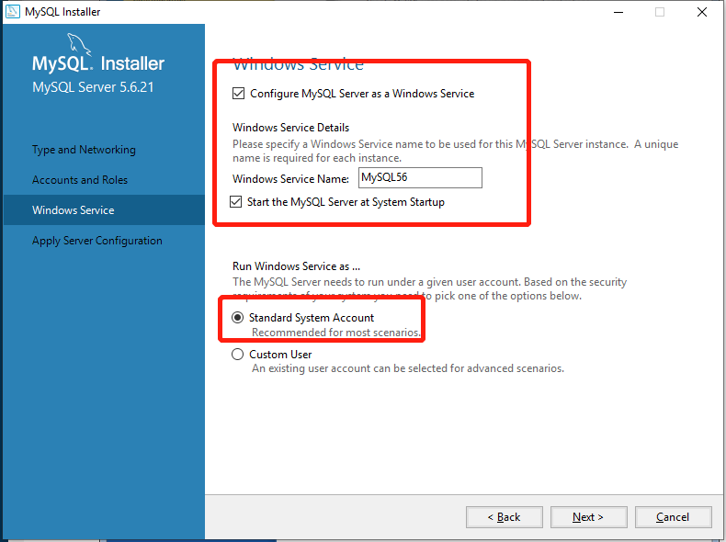

Click the “execute” button to apply the change.

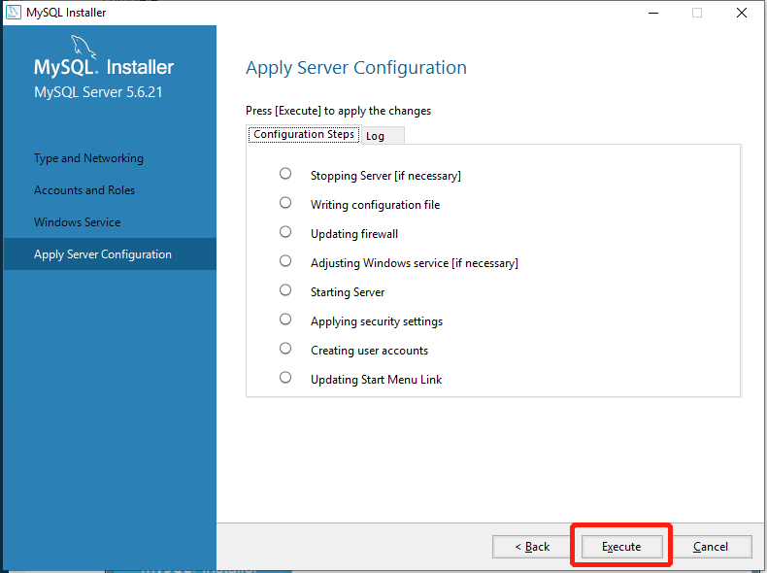

Click **Finish** to close the wizard and complete the installation

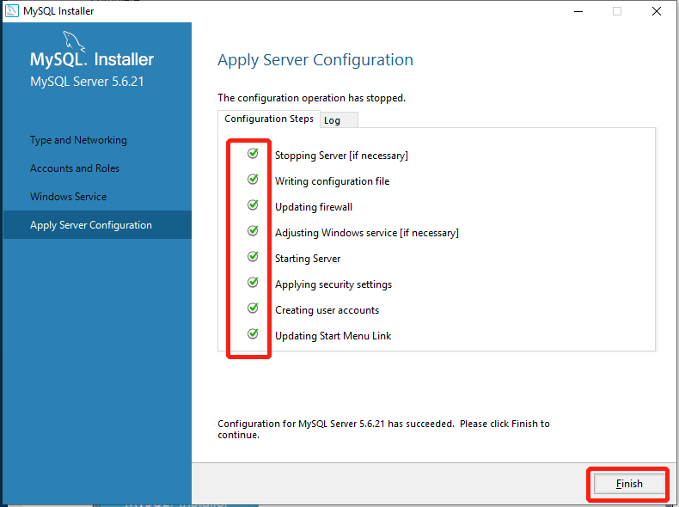

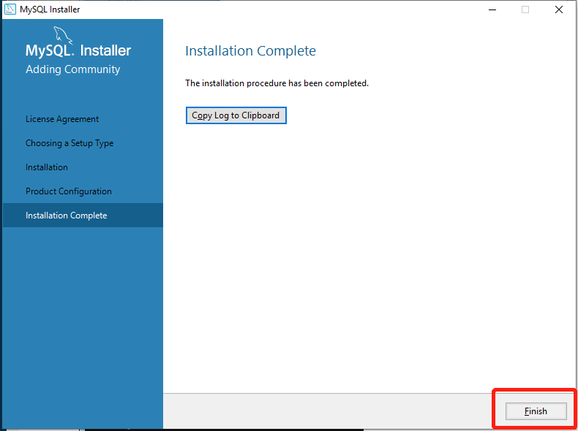

MySQL 5.6 Command Line Client

## Set Environment Variable

Update system environment. In system variables, select the “path” and then click the “edit” button.

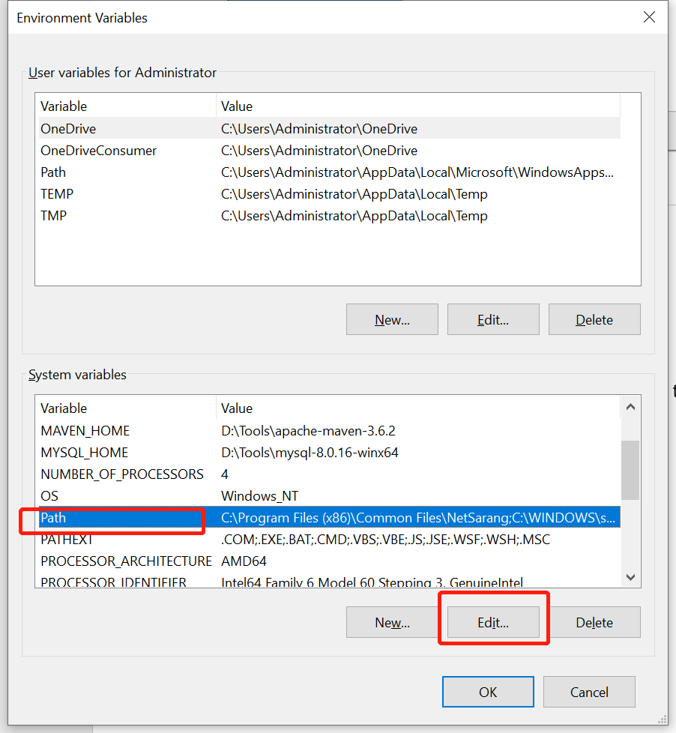

Open a new command prompt and type in (the installation directory of MySQL)”. For instance, the installation directory is “C:\Program Files\MySQL\ MySQL Server 5.6\bin”

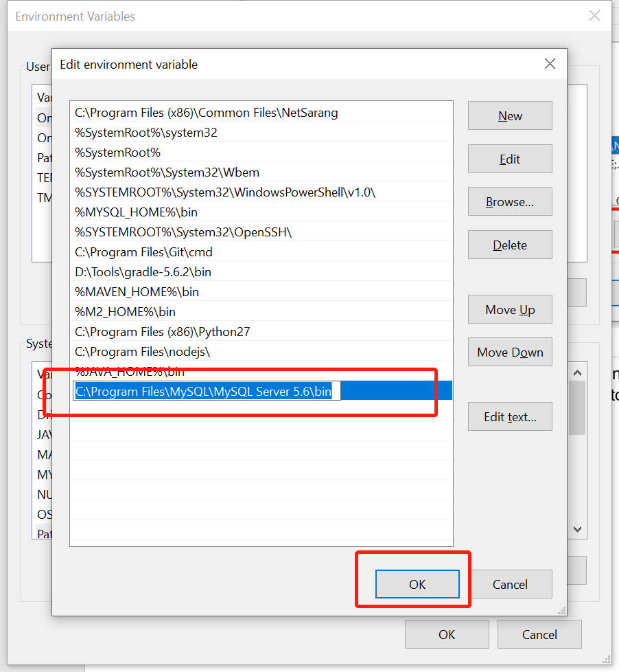

## Validation the effectiveness of MySQL

Open Command Prompt (make sure you run as administrator) and type in “mysql -u root -p”.



The system asks to type the password.

If the screen shows as the following, that means the MySQL installation was successful.

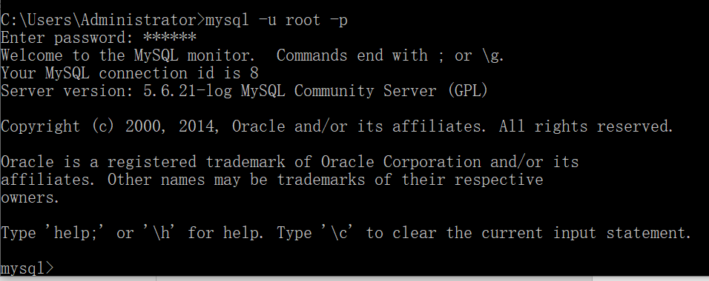

## Initialize data

Run the “Initialize data.bat” and then type the password of the database;

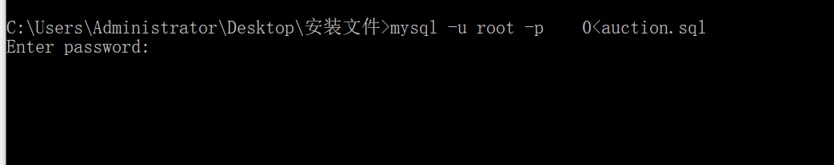

It will be automatically installed

# Tomcat

## installs

1. Copy the tomcat directory provided by the project team to the server. The tomcat name is apache-tomcat-9.0.21



1. Entry the tomcat directory/ apache-tomcat-9.0.21/bin and run startup.bat file.

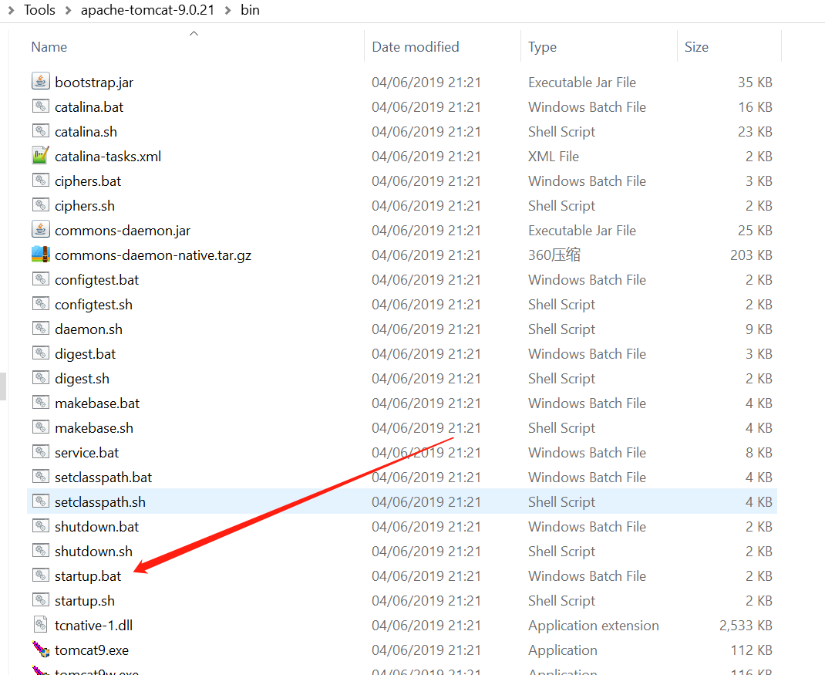

A few seconds later, the console shows the server has been started.

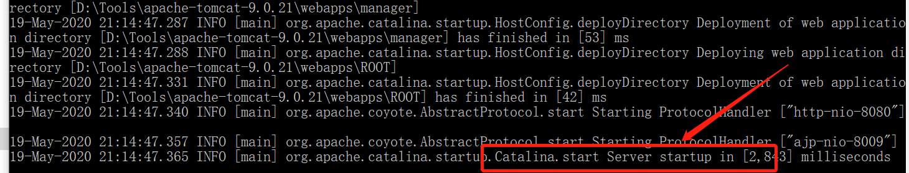

## Validation

Open the browser and type the http://localhost:8080 in the address.

If it can show the main page, this means the server start successful.

